**All about bond ETFs**

[Samara Cohen](https://www.ishares.com/us/biographies/samara-cohen) Sep 28, 2023

[Fixed Income](https://www.ishares.com/us/taxonomy?tag=Fixed+Income)

**INTRODUCTION**

It's no surprise that the growth of bond ETFs has raised some questions about their size, mechanics, and role in financial markets. Here, we look to answer some of the most popular questions we receive about bond ETFs.

Key takeaways include:

* **Size and market share:** While bond ETFs are growing, they still only account for about 1% of global bond markets.1
* **Strategic management:** Contrary to the term "passive", which is commonly used to describe index-tracking ETFs, bond ETF portfolio management is a hands-on process.
* **Price discovery:** Bond ETFs can serve as a crucial mechanism for price discovery for underlying bond exposures, especially in times of market stress.
* **Enhanced liquidity:** Bond ETFs can be net contributors to market liquidity thanks to robust secondary market trading activity (where ETF shares exchange hands between buyers and sellers).
* **Diverse use cases:** Bond ETFs can be a versatile investment tool used in a variety of ways by a wide range of both institutional and individual investors.

**SIZE AND MARKET SHARE**

**1. How big is the global bond ETF market?**

As of June 2023, there were over 900 bond ETFs globally with total assets under management (AUM) of nearly $1.9 trillion (**Figure 1**). In the U.S. — the biggest bond ETF market — the largest bond ETF categories include U.S. Treasury ($417 billion), Investment Grade Corporates ($392 billion), and Multi Sector ($348 billion). Collectively, they constitute 61% of the total global bond ETF AUM.2

Figure 1: Global bond ETF AUM ($ USD)³

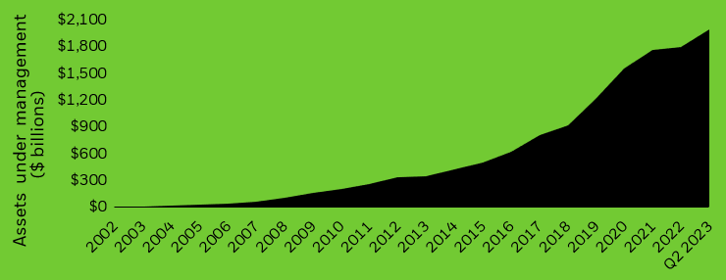

**Chart description:** Graph illustrating the growth over time in assets under management ($ billions) of the global bond ETF market.

**2. How big are bond ETFs relative to the global bond market?**

Despite their rapid growth, bond ETFs are still only a fraction of the global bond market. With AUM of approximately $1.8 trillion, global bond ETFs account for roughly 1% of the global bond market (**Figure 2**).

**Figure 2: Global bond market AUM (USD)⁴**

| Caption:  Table showing the AUM (USD) breakdown of various market segments in the global bond market. | |
| --- | --- |
| **Market segment** | **AUM** |
| Global index-tracking bond ETFs | $1.7T |
| Global active bond ETFs | $101B |
| Global index-tracking bond mutual funds | $1.3T |
| Global active bond mutual funds | $7.1T |
| **Total global bond** | **$206T** |

**STRATEGIC MANAGEMENT**

**3. What is BlackRock’s process for managing index-tracking bond ETFs?**

[iShares bond ETFs](https://www.ishares.com/us/strategies/invest-with-bond-etfs) are managed by global teams of fixed income professionals who have deep trading and portfolio management expertise. BlackRock PMs utilize a combination of technology, index research, and skill to pursue investment objectives while balancing tracking error, liquidity, and transaction costs.

BlackRock’s flexible portfolio management process allows fixed income PMs to proactively, dynamically, and efficiently execute changes in ETF portfolios as the market evolves.

For example, to account for new additions to an index, PMs will often participate in the new issue market, adjust portfolios throughout the month (instead of rebalancing on a single day at month-end), and aim to avoid situations that may result in forced buying or selling.

By participating in the new issue market, BlackRock PMs can acquire a bond when it is issued rather than at month-end when it is added to the index. This can offset some of the transaction costs (like the bid-ask spread) of buying the bond in the secondary market after issuance.5

**4. How do bond ETFs track index performance?**

For index-tracking bond ETFs, BlackRock’s PMs seek to track the performance of an ETF’s underlying index as closely as possible. However, the unique attributes of the bond market can make it challenging for a bond ETF to fully replicate (or hold every single bond) in a bond index, which can include thousands of securities. Instead, PMs often use a representative sampling strategy. Through this approach, PMs can deliver risk and return characteristics that are similar to that of the bond index by holding a subset of the index’s securities.

To do this, the PM divides each index into groups of bonds with specific risk factors (such as maturity, credit rating or sector), then selects bonds from each group to build a portfolio that closely represents the characteristics of the underlying index, such as yield and duration, to replicate the index returns as closely as possible (**Figure 3**). As a result, bond ETFs will often be composed of fewer securities than the index itself, which can result in greater portfolio management and cost efficiencies.

Figure 3: Example of sampling in a bond ETF⁶

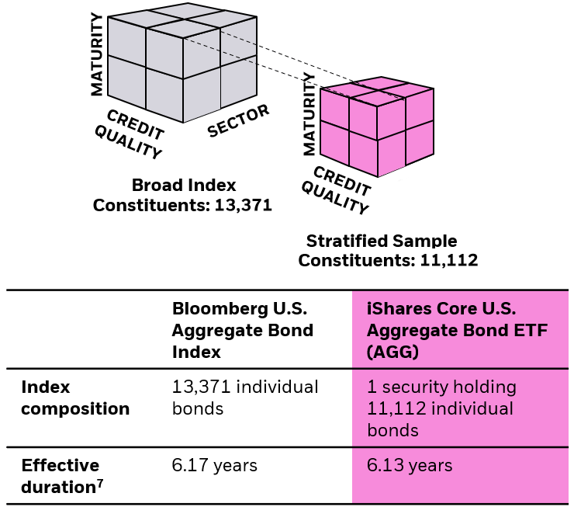

**Chart description:** Figure illustrating the stratified sampling process for index fund management. This shows that stratified sampling results in an index fund holding less constituents than the underlying index that it seeks to track but will have similar characteristics such as effective duration.

**PRICE DISCOVERY**

**5. How do bond ETFs enable price discovery?**

While an ETF’s market price is informed by the value of its underlying holdings, an ETF may trade at a price above (premium) or below (discount) its net asset value (NAV). Premiums and discounts may arise for a number of reasons, including market conditions and the nature of the underlying market (for example, if bonds are difficult to purchase or sell, or if the market is closed). During these times, the market price of the ETF (which is updated in real-time based on supply and demand conditions) can more accurately reflect the current value of underlying bonds compared with the NAV, which is only calculated once per day and may be based on estimated bond pricing if the underlying bonds were not traded that day. This highlights how bond ETFs can be used as price discovery vehicles.

For example, during March 2020, when many bond markets faced severe liquidity challenges, bond ETFs saw record volumes. While many bond ETFs traded at a discount to NAV, ETF prices more accurately reflected bond market conditions. As liquidity began to improve in the underlying bond market, discounts decreased, and bond ETFs began to trade more in-line with NAVs (**Figure 4**).

Figure 4: Price discovery in action: Premiums and discounts converge back to NAV March 2020⁸

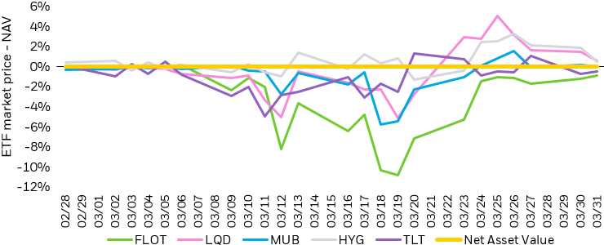

**Chart description:** Line chart showing the concept of price discovery in action during March 2020 for FLOT, LQD, MUB, HYG, and TLT.

**6. What are custom baskets and what role do they play in managing bond ETFs?**

Creation and redemption baskets for ETF shares — the baskets of securities that authorized participants can deliver to or receive from an ETF in exchange for ETF shares — are a key component of the ETF creation and redemption process. This is the process that adjusts the number of ETF shares outstanding and helps keep an ETF’s price aligned with the value of its underlying securities. Creation and redemption baskets are typically in one of two formats: pro-rata or custom. The approach used is determined by the ETF portfolio manager on a fund-by-fund basis.

* **Pro-rata basket:** Increases or decreases the fund uniformly relative to its reference index (based on daily fund holdings).
* **Custom basket:** Used to fine tune portfolio risk, tax efficiency and liquidity needs.

When full replication of an index is not feasible due to the sourceable universe, BlackRock PMs may employ a representative sampling strategy. This management technique allows the PM team to effectively manage the tracking and risk profile of the portfolio without sourcing every bond in the index.9 This management technique is complementary to our in-kind custom basket process. BlackRock fixed income ETF PMs typically use custom baskets to deliver cost efficiencies and flexibly manage ETF portfolios in line with the ETF’s underlying index.10

**ENHANCED LIQUIDITY**

**7. How do bond ETFs add liquidity to bond markets?**

Bond ETFs offer liquidity and transparency to bond markets. Where individual bonds trade in over-the-counter markets and may not trade daily, bond ETFs are generally traded thousands of times throughout the day on-exchange.

Bond ETFs are typically at least as liquid as their basket of underlying securities and are often more liquid thanks to the on-exchange trading of ETF shares. Primary market trading (where ETF shares are created or redeemed) accounts for a small percentage of ETF trading activity, which means most ETF trading activity takes place in the secondary market and does not require the ETFs to transact in the underlying bonds. This is even more evident in times of market volatility. Global financial markets experienced increased turbulence in March 2023, as the MOVE Index, a measure of interest rate volatility, reached elevated levels that were last seen in 2008 during the financial crisis (**Figures 5-6**).

Figure 5: iShares bond ETF secondary market trading volumes¹¹

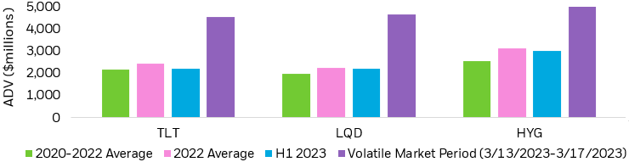

**Chart description:** Three bar charts showing iShares bond ETF secondary market trading volumes for three funds, TLT, LQD, and HYG. Secondary market volumes increased significantly in March 2023 as global financial markets experienced increased turbulence. For instance, the MOVE Index, a measure of interest rate volatility, reached elevated levels not seen since 2008.

**Figure 6: iShares bond ETF secondary to primary market trading volumes (as ratios)¹²**

| Caption:  Table illustrating the secondary-to-primary market trading volume ratios for iShares bond ETFs, demonstrating that ETF trading predominantly occurs in the secondary market, independent of underlying bond transactions, even during market volatility. | | | |
| --- | --- | --- | --- |
|  | **[iShares 20+ Year Treasury Bond ETF (TLT)](https://www.ishares.com/us/products/239454/ishares-20-year-treasury-bond-etf)** | **[iShares iBoxx $ Investment Grade Corporate Bond ETF (LQD)](https://www.ishares.com/us/products/239566/ishares-iboxx-investment-grade-corporate-bond-etf)** | **[iShares iBoxx $ High Yield Corporate Bond ETF (HYG)](https://www.ishares.com/us/products/239565/ishares-iboxx-high-yield-corporate-bond-etf)** |
| **2020-2022 average** | 13.1 | 7.4 | 9.9 |
| **2022 average** | 14.5 | 18.1 | 10.5 |
| **H1 2023** | 17.4 | 8.7 | 11.8 |
| **Volatile market period (3/13/2023-3/17/2023)** | 46.1 | 19.1 | 14.1 |

**8. How do bond ETF trading costs compare with the cost of trading underlying bonds?**

Bond markets are vast and often opaque as many bonds do not trade each day. Meanwhile, most ETF trading occurs in the “secondary” market, or on-exchange, where investors buy and sell existing ETF shares. The direction of secondary market trading volume on the exchange (i.e., buying or selling pressure) dictates where the ETF trades relative to the value of its underlying bonds.

Bond ETFs generally have tighter bid-ask spreads than their baskets of underlying securities, especially in periods of market stress, and have historically demonstrated lower trading costs compared to individual bonds, offering a more efficient and cost-effective way to enter or exit the bond market (**Figure 7**).

Market makers, broker-dealers that regularly provide two-sided (buy and sell) quotes to investors, are key liquidity providers in the ETF ecosystem and help efforts to ensure continuous, efficient, and tight ETF bid-ask spreads in the secondary market.13

Figure 7: iShares 20+ Year Treasury bond ETF (TLT) bid-ask spread compared to 20+ year treasury bid-ask spread (underlying bonds)¹⁴

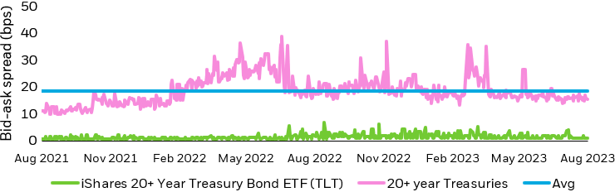

**Chart description:** Line chart showing how bond ETFs generally have tighter bid-ask spreads than their baskets of underlying securities using the case of the iShares 20+ year Treasury bond ETF (TLT) bid-ask spread compared to 20+ year treasury bid-ask spread (underlying bonds).

**9. How do bond ETFs perform in volatile markets?**

Bond ETFs have historically demonstrated  resilience during periods of heightened market volatility. Their unique structure, along with a well-established ecosystem and robust secondary market liquidity, help provide transparent and timely price discovery as well as reliable market access, liquidity, and stability, even in turbulent market conditions.

For example, bond ETFs showcased their robust performance amidst the volatile periods characterized by the COVID-19 health crisis in the spring of 2020 and the global banking crisis in March 2023. During March 2020, for example, bond ETFs set record volumes on exchange (~2x compared to 2019), providing a needed source of liquidity that allowed investors to adjust portfolios and manage risk.15

As illustrated below, the iShares iBoxx $ High Yield Corporate Bond ETF (HYG) accounted for a greater proportion of the overall high-yield trading volume during periods of heightened stress, reflecting how investors increasingly turned to ETFs as a vehicle for market access. (**Figure 8**).

Figure 8: iShares iBoxx $ High Yield Corporate Bond ETF (HYG) trading volumes as a percentage of over the counter (‘OTC’) cash volumes¹⁶

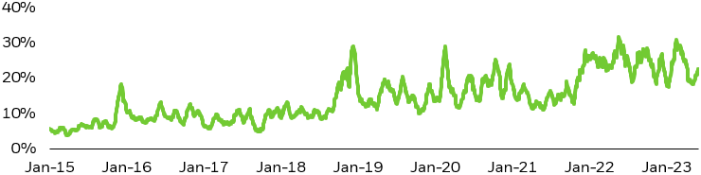

**Chart description:** Line chart showing iShares iBoxx $ High Yield Corporate Bond ETF (HYG) trading volumes as a percentage of over the counter (‘OTC’) cash volumes, showcasing the growing preference for ETFs as a means of market access.

**DIVERSE USE CASES**

**10. What are some common use cases for bond ETFs?**

The changing regulatory landscape has had impacts on the liquidity of cash bonds. Post-financial crisis regulations have contributed to a shift in how broker-dealers manage bond inventory, and finding actionable bids and offers on individual bonds can be difficult, especially when few corporate bonds trade daily. Consequently, investors are increasingly turning to bond ETFs to reap some of the benefits of accessing the market via ETFs, including:

* **Low Cost:** Bond ETFs provide a cost-effective investment option, often with lower expense ratios compared to actively managed funds.
* **Enhanced Liquidity:** Bond ETFs help enhance market liquidity, allowing investors to efficiently buy or sell positions, even in dynamic market conditions.
* **Ease of Use:** Bond ETFs simplify access to the bond market by making investing in fixed income, through ETFs, as easy as buying a stock.

Moreover, they’re a versatile tool that serves a broad range of audiences. Notably, individual investor trading activity in bond ETFs accounted for over 15% of total bond ETF volume in Q2 2023, up from 13% in Q1 2023.17

Institutional investors also leverage bond ETFs across a spectrum of applications, including to optimize their investment strategies. For instance, a client was concerned about taxes after moving to a high-tax state. In response, their asset manager decided to rebalance a sizable portion of the portfolio and allocate to municipal bonds. To minimize implementation delay, the asset manager decided to allocate to the [iShares National Muni Bond ETF (MUB)](https://www.ishares.com/us/products/239766/ishares-national-amtfree-muni-bond-etf) for immediate exposure due to the added liquidity provided by secondary market (exchange) trading. As more municipal bonds became available, the client used MUB's liquidity to transition out of the ETF and into individual bonds with efficient execution.